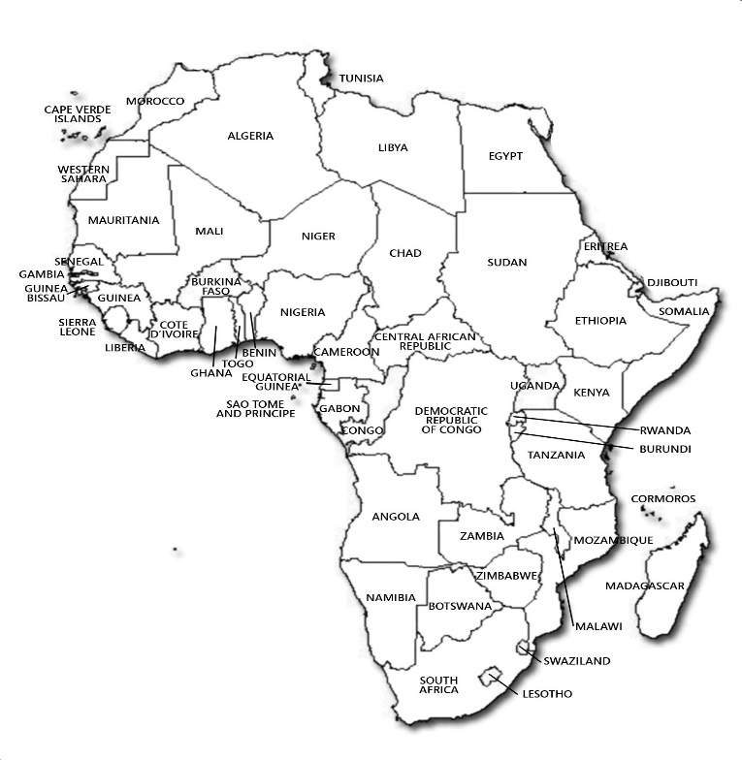
Decolonisation and the Developing World - Africa
Kenya
Algeria
Democratic Republic of Congo

Nigeria
Ghana

