Causes of the Industrial Rev : (2) Factories
Bakewell
Belper
How did the Industrial Revolution spread from countryside to city ?
Walking Through History (series 1 ; episode 1)

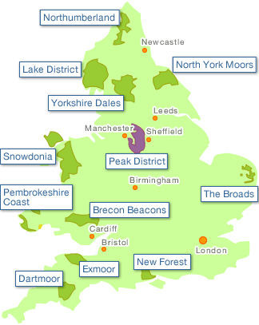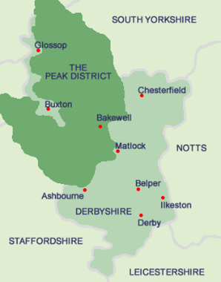
Cromford
Derby

For each place note down :
- What developments took place there ?

- How did they contribute to the IR ?

- How did they help the IR spread to cities ?

