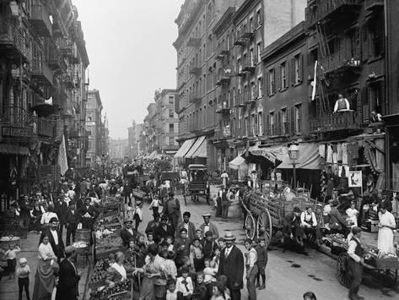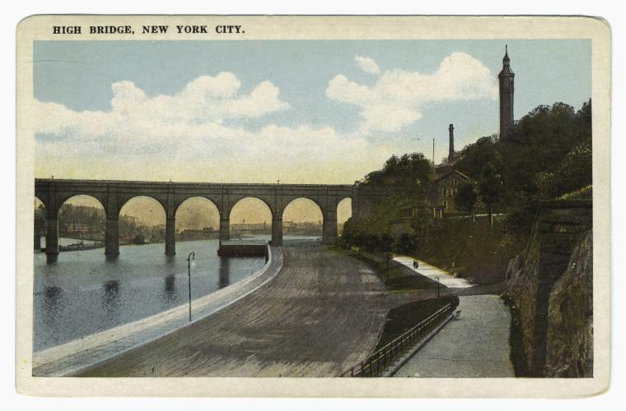
Filthy Cities – New York 1900

Using the documentary presentation, note down the negative effects of:
- Urbanisation + pop growth
- Industrial expansion
- City life
Also note down the solutions the authorities created and put into practice

Little Italy, New York City 1900 Croton Aquaduct, New York City 1900

