Chicken & Tarragon Tray Bake with couscous (+vegetarian tray bake alternative)

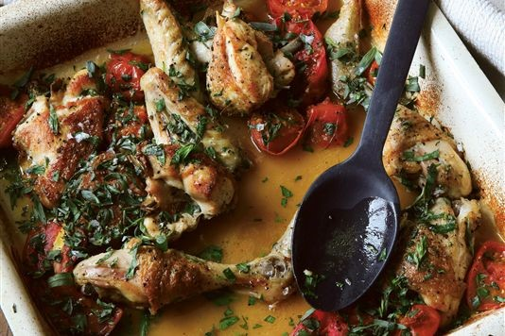

- 8 chicken thighs / 4 thighs + 4 drumsticks
- 2 tbsp olive oil
- 1/2 glass of white wine (or use water if you prefer)
- 1/2 lemon, juice only
- 500 g ripe tomatoes (any shape or size), halved or quartered
- 1 bunch of tarragon, leaves only, coarsely chopped (v large bunch of parsley if no tarragon)
- 1 pinch sea salt and freshly ground black pepper
- 180g couscous
- knob of butter
- 1 chicken stock cube, 500ml boiled water

- oilve oil, white or rose wine
- 2-4 onions, leeks
- green yellow peppers
- Cubed squash or sweet potato
- 500 g mushrooms
- pumpkin seeds, pine nuts, feta cheese

Method - chicken tray bake
- Preheat the oven to 190°C/Gas 5. Season the chicken pieces well all over with salt and pepper. You'll probably need to sear them in two batches.
- Heat the olive oil in large non-stick frying pan over a medium-high heat, add the chicken and sear, turning the pieces several times, until they are golden brown all over. Transfer, skin side up, to an oven dish or roasting tin.
- Now, to deglaze the frying pan, pour in the wine and let it bubble over the heat, stirring well to scrape up any bits of caramelized chicken from the bottom. Pour the liquid from the pan into the oven dish (but not directly over the chicken). Add the lemon juice and give the chicken skin an extra scattering of salt and pepper. Cover the dish with foil and bake for 30 minutes.
- Take the dish from the oven, uncover and add the tomatoes, nestling them, cut side up as far as possible, among the chicken pieces. Roast, uncovered, for a further 20 - 25 minutes, or until the chicken pieces are cooked through and the tomatoes are soft and blistered.
- Last 5 minutes, scatter over most of the tarragon and toss to mix.
- Put the couscous into a bowl and mix up 500ml of chicken stock - mix together in the bowl and then leave to rest for 5-10 minutes.
- Take out the chicken and rest for a few minutes so the tarragon flavour infuses the juices. Sprinkle over the remaining chopped tarragon and the dish is ready to serve.
- Uncover the couscous and mix in small slices of butter with a fork until fluffy
(If you can't lay your hands on fresh tarragon, try this with flat-leaf parsley - using about three times as much. Or try roughly shredded sorrel leaves. In each case, the effect is quite different, but still delicious.)

Method - vegetarian tray bake

- Preheat the oven to 190°C/Gas 5.
- Add the olive oil to roasting tin, oven tray
- Chop onions and/or leeks roughly or put into a mini food processor
- Chop the peppers into half; get rid of the seeds on the inside; cut into strips
- Chop the mushrooms in half
- Add all these into the roasting tin adding the squash, pumpkin, pumpkin seeds and pine nuts and mix well
- Pour in wine at the side, season with salt and lots of black pepper
- Roast in oven for 45 minutes or until all veg is cooked - up to you how much
- Turn every 10 minutes or so
- Take out and sprinkle with feta that has been cut into small cubes

