Chicken Jalfrezi

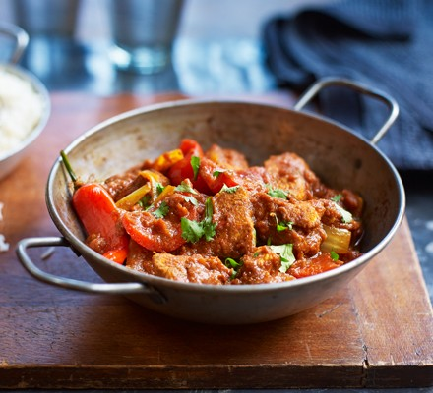

For the sauce
- ½ large onion, roughly chopped
- 2 garlic cloves, chopped
- 1 green chilli, finely chopped
- vegetable oil, for frying
- 400g can plum tomatoes
- 1 tbsp ground coriander
- 1 tbsp ground cumin
- 1 tsp turmeric

For the meat & veg
- 2-3 chicken breasts, diced
- 1 tsp ground cumin
- 1 tsp ground coriander
- 1 tsp turmeric
- ½ large onion, sliced
- 1 red pepper, chopped
- 2 red chillies, finely chopped (optional)
- 2 tsp garam masala
- handful of fresh, chopped coriander leaves

- Cooked basmati rice, naan bread or flatbreads to serve....

Method
- Take 2-3 diced chicken breasts and coat in 1 tsp cumin, 1 tsp coriander and 1 tsp turmeric then leave it to marinate in the fridge while you make the sauce.
- To make the sauce, fry ½ roughly chopped large onion, 2 chopped garlic cloves and 1 finely chopped green chilli in a large pan with a little vegetable oil, for around 5 mins, until browned.
- Add 300ml water to the onion mixture and simmer for around 20 minutes.
- Meanwhile, put a 400g can plum tomatoes in a food processor and give it a good whizz (aim for a smooth consistency).
- Heat another large pan and gently fry 1 tbsp coriander, 1 tbsp cumin and 1 tsp turmeric in a splash of oil for about a minute. Add the tomatoes to this pan and simmer for around 10 minutes.
- Next, whizz your onion mixture in the food processor and add it to the spiced tomato sauce. Season generously, stir, then simmer for 20 minutes. You can make large batches of this sauce and freeze it for later use by doubling up the ingredients leaving you with an easy and quick curry to cook....
- Fry the marinated chicken in vegetable oil and stir continuously. After a few minutes, turn down the heat and add the remaining ½ sliced onion, 1 chopped red pepper and 2 finely chopped red chillies.
- Stir until the onions and pepper soften.
- Add the sauce you prepared earlier to the cooked chicken and simmer for around 10-20 minutes, adding a splash of water if it gets too thick.
- Whilst the curry is finishing off, measure out half a mug (2 people) or a mug (4 people) of uncooked rice. Add double the amount of boiling water to a small lidded saucepan on medium heat (1/2 mug rice = 1 mug boiling water for example).
- Add rice to water when it is bubbling. Cook on a low medium heat for 10 minutes WITHOUT TAKING OFF THE LID!!! Take off the heat after 10 mins...
- Just before you dish it up, stir in 2 tsp garam masala and handful of chopped coriander leaves.
- Serve with basmati rice or naan bread.

