Questions: Cold WAR CRASH COURSE #39
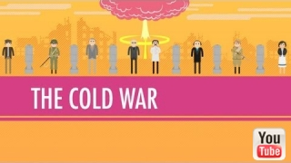
Directions: Watch the video “USA vs. USSR Fight! The Cold War: World History Crash Course #39” on www.youtube.com and answer the questions below on a separate piece of paper.
- What was the Cold War? Describe the ideological struggle that was the basis for this conflict.
- Why did the Soviets build the Berlin Wall in 1961?
- What was the purpose of the U.S. policy of containment and in what ways was it used to slow the spread of communism?
- What was the MAD policy and why did both the US A and USSR agree to it?
- Identify and describe one “hot” proxy war fought during the Cold War.
- The Cold War led to the division of the planet into three worlds. Identify and briefly describe each of these three worlds.
- What nation eventually would win the Cold War? Why did the Cold War end when it did?
- What individual is most responsible for bringing an end to the Cold War? Why?
------------------------------------------------------------------------------------------------------------------------------------------

