What and why carry out a literature review?

How can you expect your extended essay to go forward without knowing what has already been written about the topics and themes you are investigating? Do not let the phrase ‘literature review’ intimidate you. Yes, you have to read texts and, yes, you have reflect on what you have read but it is not a study of literature in traditional sense, ie Shakespeare’s sonnets or Coleridge’s couplets.

WHAT IS THE PURPOSE OF A LITERATURE REVIEW?

Before writing about any topic it is useful to find out what has already been said about the topic.

This allows you to:
- Better understand the topic
- Make a link between your ideas (or methods) and those of others
- Consider whether your ideas challenge or support an existing consensus
- Situate your views within a context of existing viewpoints
- Track any major trends or patterns in terms of interpretation
- Allow you to identify the value and limitations of source material

Lekanides (58)

SUPER TIPS ABOUT LITERATURE REVIEWS

The literature review enables you to say “Evans and Adams have found this’ or ‘There’s a gap here’, or “Bloggs is disagreeing with Smith; I wonder why that is’, or ‘Brown and Jones both say this, but it disagrees with the general scientific view’, or public opinion is disputed by Davies, who says … ‘ … or something else like this.

Now, as you do your literature review, or desk research, you will almost certainly think about changing your [initial research] question. This is normal; don’t worry about it. In fact, it is more than normal: it is necessary. It’s part of the clearing the ground process. It is necessary that you should revisit your question, that you should say:

- ‘Oh, I hadn’t thought of that’, or
- ‘Oh, that has already been done by Bloggs, so I won’t bother’, or
- ‘Oh, no one has looked at this; I think I’ll look at this instead.’

Once you have your information from your literature searches you need to make sense of it and to knit it into a meaningful story. One of the big problems of students literature reviews is that they look like lists (Bloggs says x; Jones says y; Smith says z) rather than stories. Your literature review should be more like a story than a list. You should be connecting this bit with that bit, saying how this fits but that doesn’t, and showing how there is a theme (or not) through the literature that you are reviewing. If, inconveniently there is not a theme, say so. Suggest some reasons why this might be.
Don’t be fazed by the differences in opinion that you find. Take pleasure in them, and use them to understand your field of study. As in any human endeavour there are disagreements, rivalries, conflicts, friendships and even cabals amongst the professional researchers. Try to understand why these exist: try to create a story and explain the story. Then, use your understanding to modify your initial questions. You can then progress from here.

Thomas Chp7

The diagram below provides a simple insight to a few of the major benefits of carrying out a literature review. Notice the feedback loop and the improved research question as a result.

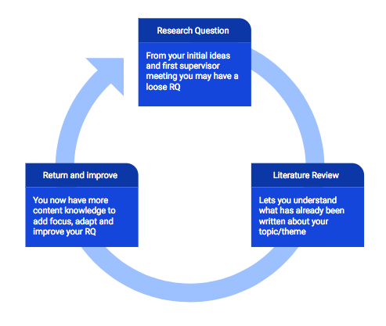

ONLINE HELP

- University of Kent, UK
- University of Edinburgh, UK
- University of Middlesex, UK
- The Open University, UK
- Royal Literary Fund, UK
- Engage in Research.ac.uk
- Palgrave Study Skills

