Questions: WORLD WAR II Crash Course #38
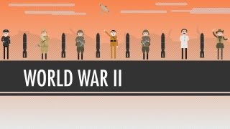
Directions: Watch the video “World War II: World History Crash Course #38” on www.youtube.com and answer the questions below on a separate piece of paper.
- Describe the military tactic known as the blitzkrieg? How did it give the Nazis such an advantage in first few months of World War II?
- Identify and briefly describe why 1941 was a big year in World War II.
- What happened at the Battle of Stalingrad (1942) and why was this battle so important in World War II?
- What was the definitive cause of World War II? Describe how “food” played a major role in the decisions that led to the war in both Europe and Asia.
- Why is World War II so important in World History? (Briefly explain your answers.)
------------------------------------------------------------------------------------------------------------------------------------------

