Causes of Great Depression

Long term factors
- The 1920s witnessed an economic boom in the US (typified by Ford Motor cars, which made a car within the grasp of ordinary workers for the first time). Industrial output expanded very rapidly.
- Sales were often promoted through buying on credit. However, by early 1929, the steam had gone out of the economy and output was beginning to fall.
- The stock market had boomed to record levels. Price to earning ratios were above historical averages.
- The US Agricultural sector had been in recession for many more years
- The UK economy had been experiencing deflation and high unemployment for much of the 1920s. This was mainly due to the cost of the first world war and attempting to rejoin the Gold standard at a pre world war 1 rate. This meant Sterling was overvalued causing lower exports and slower growth. The US tried to help the UK stay in the gold standard. That meant inflating the US economy, which contributed to the credit boom of the 1920s.

1 - Stock Market Crash of October 1929
During September and October a few firms posted disappointing results causing share prices to fall. On October 28th (Black Monday), the decline in prices turned into a crash has share prices fell 13%. Panic spread throughout the stock exchange as people sought to unload their shares. On Tuesday there was another collapse in prices known as 'Black Tuesday'. Although shares recovered a little in 1930, confidence had evaporated and problems spread to the rest of the financial system. Share prices would fall even more in 1932 as the depression deepened. By 1932, The stock market fell 89% from its September 1929 peak. It was at a level not seen since the nineteenth century.Falling share prices caused a collapse in confidence and consumer wealth. Spending fell and the decline in confidence precipitated a desire for savers to withdraw money from their banks.

2 - Bank Failures
In the first 10 months of 1930 alone, 744 US banks went bankrupt and savers lost their savings. In a desperate bid to raise money, they also tried to call in their loans before people had time to repay them. As banks went bankrupt, it only increased the demand for other savers to withdraw money from banks. Long queues of people wanting to withdraw their savings was a common sight. The authorities appeared unable to stop bank runs and the collapse in confidence in the banking system. Many agree, that it was this failure of the banking system which was the most powerful cause of economic depression. Because of the banking crisis, Banks reduced lending, there was a fall in investment. People lost savings and so reduced consumer spending. The impact on economic confidence was disastrous.
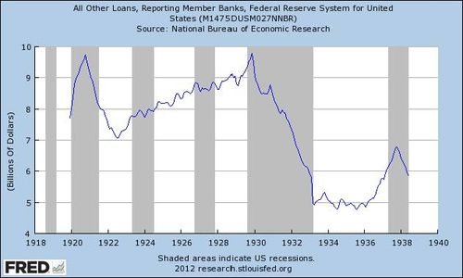
50% fall in bank lending during the Great Depression. Period in grey - recessions.

3 - Deflation
With falling output, prices began to fall. Deflation created additional problems.
- It increased the difficulty of paying off debts taken out during 1920s
- Falling prices, encouraged people to hoard cash rather than spend (Keynes called this the paradox of thrift)
- Increased real wage unemployment (workers reluctant to accept nominal wage cuts, caused real wages to rise creating additional unemployment)

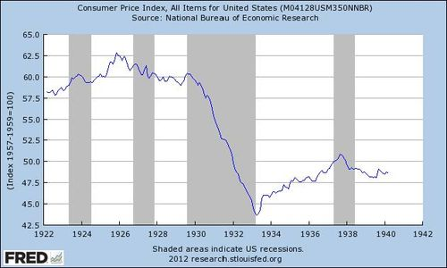

US price level. 1930-33 was a period of deflation (negative inflation) – a fall in price level.
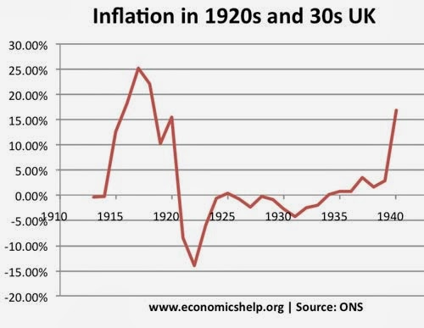
The UK also experienced a long period of deflation in 1920s and 1930s

4 - Unemployment and Negative Multiplier Effect
As banks went bankrupt, consumer spending and investment fell dramatically. Output fell, unemployment rose causing a negative multiplier effect. In the 1930s, the unemployment received little relief beyond the soup kitchen. Therefore, the unemployed dramatically reduced their spending.
5 - Global Downturn
America had lent substantial amounts to Europe and UK, to help rebuild after first world war. Therefore, there was a strong link between the US economy and the rest of the world. The US downturn soon spread to the rest of the world as America called in loans, Europe couldn't afford to pay back. This global recession was exacerbated by imposing new tariffs such as Smoot-Hawley which restricted trade further.

