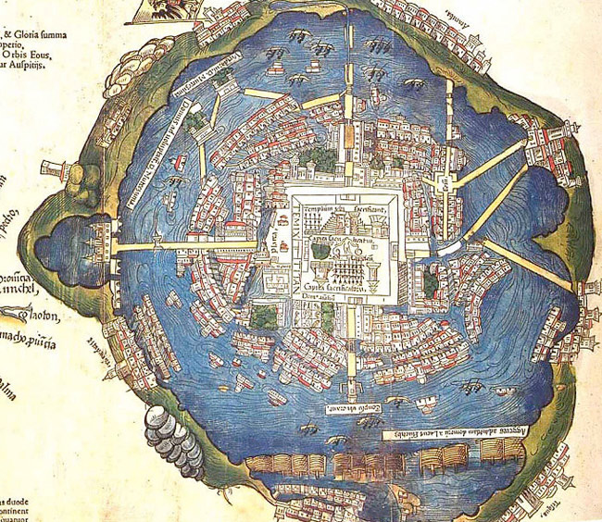 Tenochtitlan : City of the Gods....

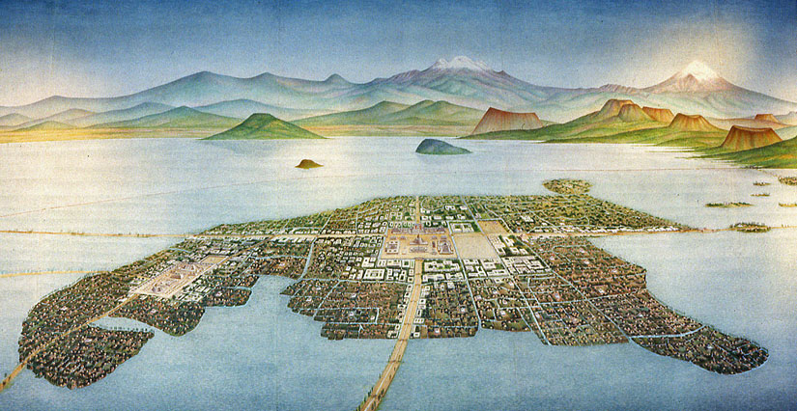

As Spanish soldiers, newly landed in the New World, you have already survived weeks at sea without really knowing where you are going. Since then, you've been surrounded by new sights, sounds, smells in a world beyond your imagination. However, nothing can prepare you for your first visit to the Aztec capital - Tenochtitlan: City of the Gods.

Your job is to try and communicate to the Spanish people back home what this incredible creation is like, as it seemingly floats on a shimmering lake and is connected to land by a huge earthen bridge on which a constant stream of traffic trundles in and out of the city.

Using your research, you must write a letter home covering the wonders of the city itself (the surroundings, the architecture); the daily life of the people around you (how they dress, what they do, what they're like); as well as the aspects of life that terrifies you (the ritual sacrifice, the numbers of people, the insects and disease etc.) These must be described in detail using examples and backed up with drawings and illustrations (at least one being your own...)

Best of luck - remember, your job is to communicate sights and experiences never seen before so be as colourful and descriptive as possible...

