Chow Mein

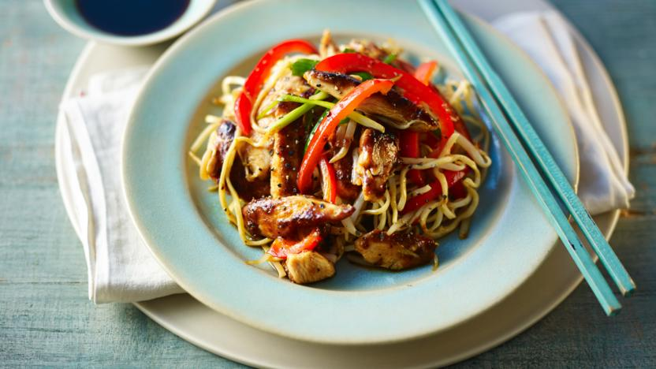

Ingredients
- 350g medium egg noodles
- 350g skinless chicken breast fillets or rump steak slices, sliced into strips (or Quorn for veggy)
- 8-10cm piece of ginger
- 2-3 garlic cloves
- 1 red pepper, seeds removed and thinly sliced
- 200g/5oz bean sprouts
- 150g mange tout/sugar snap peas cut in half
- handful of mushrooms quartered
- 3 spring onions, sliced lengthways and finely chopped
- toasted sesame oil
- rice vinegar (dry sherry will do if you can't find rice vinegar)
- 4 tbsp light soy sauce
- 2 tsps five-spice powder
- 2 tbsp groundnut/rapeseed oil
- freshly ground black pepper
- 2 tsp chilli sauce (optional)
- 4 tsps oyster sauce (optional - only with the beef)

Method

- Cook the noodles in a pan of boiling water for 2–3 minutes, until al dente, or according to packet instructions. Drain, then rinse under cold running water and drain again. Drizzle with a dash of sesame oil and toss through to prevent the noodles from sticking to each other.

- Peel the ginger and grate on a fine side of the grater; crush your garlic cloves
- Put the chicken/beef/Quorn strips in a bowl with the garlic and ginger, and season with light soy sauce, the five-spice powder and chilli sauce, if using...add the oyster sauce to the beef if using beef
- Mix well and put in the fridge for 10 minutes

- Prepare your vegetables (red pepper, mange tout, mushrooms, spring onions)

- Take meat or Quorn out of the fridge.
- Heat a wok until smoking and add the groundnut oil, then add the meat and marinade
- Stir fry for 3 minutes, or until the meat is golden-brown and cooked through
- Add a good dash of rice vinegar or dry sherry
- Add spring onions and mushroom - stir fry for 2 minuts,
- Then add the bean sprouts and mange tout - stir fry for 30 seconds.
- Stir in the cooked noodles and season with the soy sauce, a dash of sesame oil. more five spice and freshly ground black pepper.
- Pile the noodles onto a serving plate and serve immediately.

