Questions: Wait For it…The Mongols!
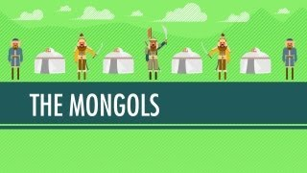
Directions: Watch the video “Wait for it… The Mongols: World History Crash Course #17” on www.youtube.com and answer the questions below on a separate piece of paper.

- The Mongols were originally nomadic herders from the steppes of Central Asia.
What are four key things to remember about nomadic herders?

-
-
-
-

- What two innovations allowed Temujin [Chinggis, or Genghis, Khan] to unite the Mongol Confederation and earn the title of Great Khan?

-
-

- Name the four empires, or khanates, that were formed out of Genghis Khan’s conquests after his death? (*Don’t forget to write the name of the khanate and its geographic location!)

-
-
-
-

- Why were the Mongol armies so successful at conquest despite their relatively small size?

- What are five arguments for Mongol awesomeness?

-
-
-
-
-

- What are five reasons why the Mongols may not have been so great?

-
-
-
-
-
Why do you think we should regard the Mongol expansion as the start of our studies into modern Europe?

Research task_
Using the videos on historychamps, uncover what each of these historical movements were, and how they changed Europe:

Black Death

Renaissance

Reformation

Scientific Revolution

Does your original decision about the Mongol expansion still seem OK? If so, why? If not, explain why not….

