Roast chicken dinner

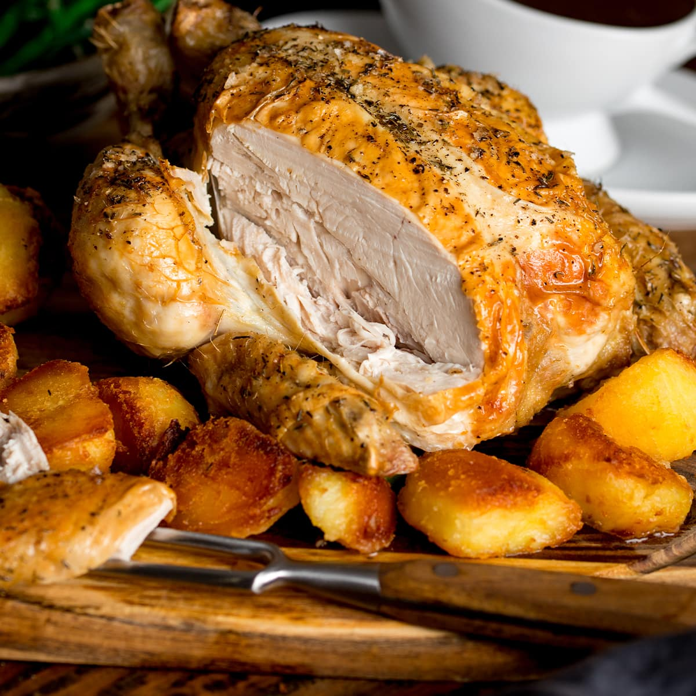

Ingredients
- 2 onions, roughly chopped
- 2 carrots, roughly chopped
- 3-4 garlic cloves in skins
- 1 free range chicken, about 1-1.5kg
- 1 lemon, halved
- small bunch rosemary or thyme (optional)
- olive oil, salt, pepper
- white wine
Side dishes
- 500g potatoes
- frozen veg of your choice - broccoli, beans, edamame

Gravy
- 50-100g plain flour
- 250ml-500ml chicken stock (a cube is fine)

Method
- STEP 1
Heat oven to maximum. Have one shelf ready in the middle of the oven without any shelves above it, one shelf on the bottom of the oven
- STEP 2
Scatter 2 roughly chopped onions, 2 roughly chopped carrots, 3-4 garlic cloves and 1/2 of your herbs over the base of a roasting tin that fits the whole chicken, but doesn’t swamp it. Halve the lemon and juice...
- STEP 3
Season the cavity of the chicken liberally with salt and pepper, then stuff with 1 lemon half divided in two and a small bunch of thyme or rosemary, if using.
- STEP 4
Sit the chicken on the vegetables, smother the breast and legs all over with olive oil, then season the outside with salt and pepper. Pour in the wine around the base of the chicken, avoiding the chicken itself
- STEP 5
Place in the oven and leave on full for 15 minutes. Then reduce the temperature to 180-190 degrees and leave undisturbed, for another 50 mins- 1 hour – this will give you a perfectly roasted chicken. To check, pierce the thigh with a skewer and the juices should run clear.

- STEP 6
Boil a large pan of water. Chop your potatoes into halves or quarters, depending on the size of your potatoes and place into your pan for 10-15 minutes. Put your frozen veg into bowls and drizzle over some boiled water from the kettle. Once the potatoes have boiled, then remove into a colander and shake. Take the very roasting tray off the bottom of the oven (CAREFUL - use oven gloves.) and add olive oil, the boiled potatoes and salt - place the tray back on the bottom of the oven. Take out every 10 minutes or so and turn over your potatoes for the next 45 minutes or so..

- STEP 7
Carefully remove the chicken from the oven and, using a pair of tongs, lift the chicken to a warmed dish to rest for 15-20 mins under foil and a towel. As you lift the chicken out, let any juices from the cavity pour out into the roasting tin.
- STEP 8
While the chicken is resting, make the gravy. Put the juices, vegetable, garlic etc from the roasting tray into a large deep frying pan (BUT take out the lemon rind). Then stir in 1, 2, 3 tbsps flour until your mixture gets thick and start cooking.
- STEP 8
Gradually pour in 250-500ml of chicken stock, stirring all the time, until you have a thickened sauce. Add extra water if needs be...
- STEP 9
Simmer for 2 mins, using a spoon to stir, scraping any sticky bits from the tin. Strain the gravy into a small saucepan, then simmer and season to taste.

- STEP 10
Put your frozen veg into the microwave for 4 minutes on 800 - strain after and keep in warmed bowls with foil or towel on top
- STEP 11
Take out the now golden potatoes and keep warm in foil whilst carving the chicken..

