To what extent does language determine our reality?
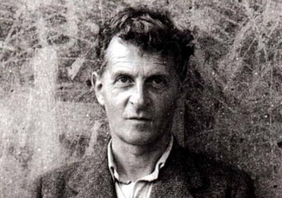
- Ludwig von Wittgenstein
- One of the few 20th century philosophers to already be viewed as great
- Spent his academic career looking at philosophy of language
- Early and late works directly contradict each other
- Demonstrates the complexity of looking at language and its role in our pursuit of knowledge

Tractatus – 1921 | Philosophical Investigations - 1953
- Language as a creation  - Reflects reality  - Structure of language reflects the structure of reality  - Real life relationships and meanings are mirrored by language  - Language determines our reality  "the limits of my language are the limits of my world" | - Language as a tool  - Reflects language games we play  - Structure of language reflects pre-determined rules of these games  - True meanings determined by the use of surface & depth grammar  - Language an innate function  “if God looked into our minds, he would  not have been able to see there of  whom we were speaking.”

- HC - TOK - Knowledge + Language - Language as Thought; Language as Commmunication
Read; match Wittgenstein’s theories in the table above to a stance on language in each section
- Relative (language depends much more on individuals and their existence)

- Universal (language depends much more on common characteristics that we all share)

- Which do you see as being more likely and why?

