Guernica Meaning:
Analysis & Interpretation of Painting by Pablo Picasso

Guernica (1937) by artist Pablo Picasso is one of the most famous paintings of all time. Like so many famous works of art, the meaning of Picasso's Guernica is not immediately clear and left wide open to analysis and interpretation. What is the meaning of Guernica, the mural by Pablo Picasso? A careful analysis and intepretation of the painting reveals the importance of Spain, war, and most of all bullfighting in Picasso's Guernica.

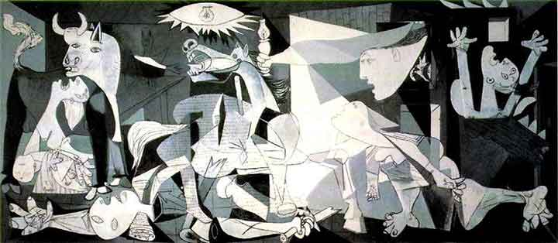

Guernica and Spain: Nationalist Art?

Picasso's homeland of Spain is central to the meaning of Guernica, a mural the artist was commissioned to paint for the 1937 World Fair in Paris. Although Picasso expatriated to Paris and never did return to Spain during his life, the artist's connection to his homeland of Spain is evident in Guernica, named after a small country town in north Spain that was the target of a terror bombing exercise by the German Luftwaffe during the Spanish Civil War.
top-responsive

"My whole life as an artist has been nothing more than a continuous struggle against reaction and the death of art. In the picture I am painting — which I shall call Guernica — I am expressing my horror of the military caste which is now plundering Spain into an ocean of misery and death."
PABLO PICASSO

Analysis of Picasso's Guernica: An Anti War Painting

As Picasso's quote suggests, Guernica is primarily a war painting, offering a visual account of the devastating and chaotic impact of war on both men and women, in this case specifically on civilian life and communities. Picasso completed the painting of Guernica in 1937, a time of widespread political unrest not just in Spain, but worldwide. World War II would begin just a couple years later and would further decimate the European continent as a whole. In Guernica, we see several victims of the bombing--some still living, some already dead. A figure sprawled supine in the foreground of the painting appears to be a corpse and is framed on both sides by living victims with their heads thrown back, wailing in agony. The figure to the left is a mother clutching a baby who appears to have died during the bombing.

Pablo Picasso's Guernica Painting Influences & Cubism

The chaos caused by Europe's political instability is evident in Guernica's composition, with humans and animals jumbled together into a background of broken hard-edged geometric shapes, reminiscent of Cubism. The newspaper print background texture of the horse may also be a throwback to Picasso's early "Journal" Cubist artwork. While art critics enjoy analyzing the use of color in Picasso's "rose" or "blue" periods, in the mostly monochromatic painting Guernica the predominant "color" is mostly black, reminiscent perhaps of death itself. Picasso's Guernica is most likely influenced by another Spanish artist, Francisco de Goya, who often painted not only war paintings, but also bullfighting art. How does bullfighting influence the meaning of Picasso's Guernica?

Tauromachia: Guernica & Traditional Spanish Bullfighting Symbolism

Humans and animals are on an equal footing in Picasso's Guernica, with the artist perhaps illustrating not only the simultaneous brutalization and dehumanization of humanity during wartime, but also the base, animalistic response that all living things, animals and humans, share in the face of fear and death. But the two animals in Guernica, the bull and the horse, may have more meaning than just that.

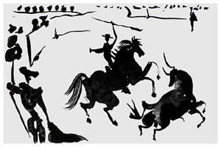
Is the meaning of Picasso's Guernica somehow related to bullfighting? Guernica can be classified as a "war painting," but the painting also features many symbols--including a bull, horse, and a man with a sword--that would fit well into traditional bullfighting art, much like Picasso's own later art and sketches like Tauromaquia (1957). The bull is the unofficial national symbol of Spain, and bullfighting is a traditional pastime or spectacle sport in Spain, with this bullfighting symbolism connecting Guernica with a specifically nationalistic meaning.

But Picasso's Guernica does not depict the traditional Spanish bullfight you might expect to see in a "nationalistic" painting. Rather than depicting a victorious matador bowing to the crowds before a slaughtered bull, in Guernica the bull remains stoically standing to the left side of the painting while the matador lays dead in the foreground, the sword or spear he might have used to slaughter the bull broken off in his hand. Like the fallen matador, his horse is also dying and anguished. Only the bull remains peaceful in Guernica, with the other figures and the entire composition of the painting turned toward the bull, an unlikely peaceful "center" for the war painting on the left side of the canvas.

"If you give a meaning to certain things in my paintings it may be very true, but it is not my idea to give this meaning. What ideas and conclusions you have got I obtained too, but instinctively, unconsciously. I make the painting for the painting. I paint the objects for what they are."
PABLO PICASSO

Interpretation & Meaning of Guernica (1937)

Even though Picasso did not like to discuss the "meaning" of his art, the nationalistic symbolism of Guernica is difficult to deny. As the unofficial national symbol of Picasso's homeland and the most resilient figure in Guernica, the bull most likely is a symbol of Spain itself, the country still "standing" even after a brutal attack. While the bull is triumphant in the painting, the overall meaning of Guernica is less optimistic, with chaos and brutality reigning over civilization, much as it did during the real life Guernica bombing attack.

