What did a trench look like? How was it built?

'1917' - opening 9 minutes
- describe what living in a trench must have been like
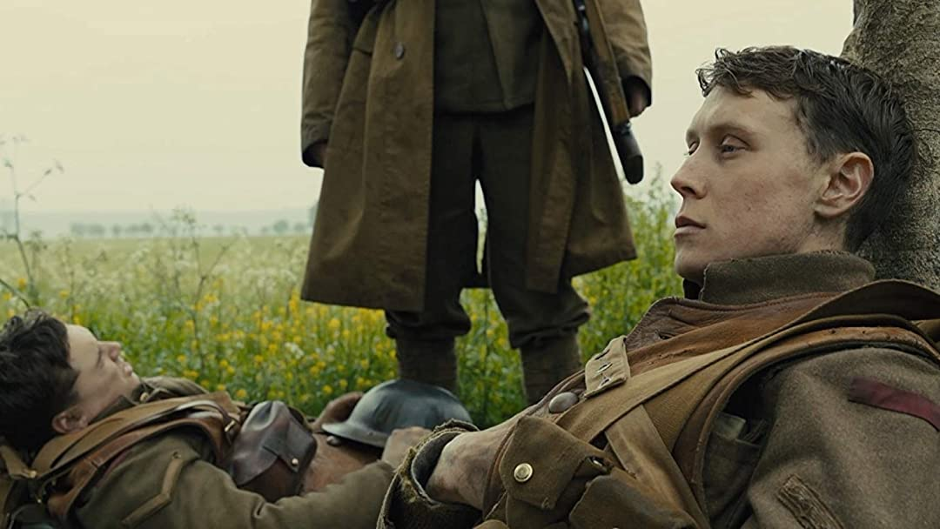
How did people live in it day to day? What facilities existed?

What conditions, challenges must
the soldiers have faced?

