**Decolonisation of Asia**

India, Pakistan, Bangladesh

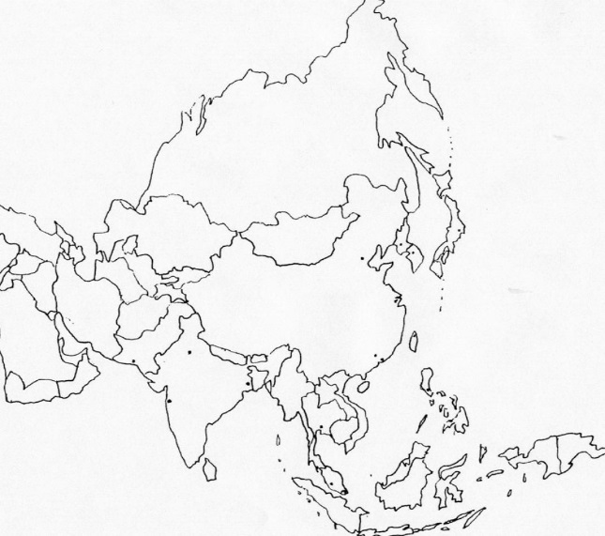

Indonesia

China

Philippines

Indochina