Questions: IMPERIALISM Crash Course #35
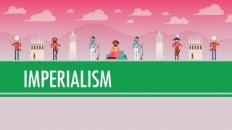
Directions: Watch the video “Imperialism: World History Crash Course #35” on historychamps.com and answer the questions below.
- What is Imperialism?

- What product in the 19th century did Europeans, especially the British, discover that the Chinese would buy, and what impact did it have on China?

- What were the provisions (results) of the Treaty of Nanjing that ended the Opium Wars?

- What was the Scramble for Africa?

- What made it possible?

- What was indirect rule?

- Why did most European nations use it to control their colonies?

- Why did local princes put up with indirect rule?

- Identify & briefly describe a non-European society that successfully (or almost successfully) resisted European rule during the 19th century?

- What was economic, or “business”, imperialism?

- Non-video question - identify an example of imperialism in the world in 2022 - who is involved and why has it occurred, or is occuring?

