Scramble for Africa – how was the continent divided up ? (wikilink…)
Motives and Tactics (pgs 515-516) Scramble for Africa (pgs 529-531)
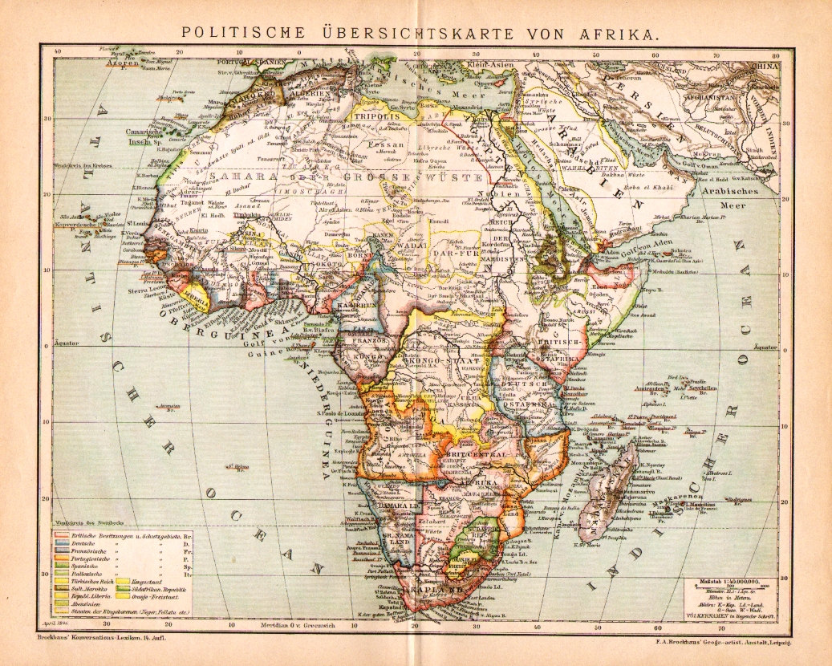

Systems of rule (pgs 532-533)
- Indirect rule

- Direct rule

