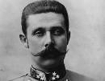 Days that shook the world – 28th June 1914 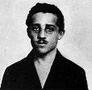

- What was happening in:

- Germany?

- Russia?

- UK & France?

- Bosnia and the Balkans?

- Who was in Sarajevo on this day and why?

- What was the involvement of the Serbian military intelligence and Colonel Apis?

- Who was Archduke Franz Ferdinand and why did Apis want him dead?

- How did the Colonel organise the assassination?

- How did Franz Ferdinand organise his parade around Sarajevo ?

- What happened when the assassins attacked?

- Mehmedbasic
- Cabrinovic
- Popovic & Cubrulovic
- Crabez
- Princip
- Ilic

- What happens to the Archduke? Where does he go after the reception?

- How does Princip get a second chance to assassinate the Archduke?

- What happens ?

- What were the results ?

