Ragu for all..

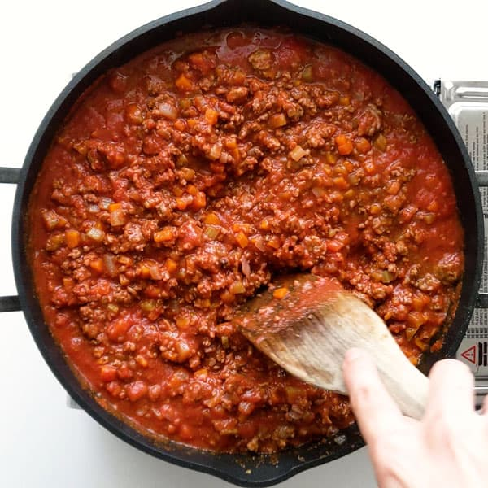

Ingredients
- 1 tbsp olive oil
- 1-2 onions
- 1-2 celery sticks
- 1 large carrot, finely diced/grated
- 500g pack minced beef / Quorn vegetarian mince or similar
- Worcestershire sauce and/or Balsamic vinegar (optional)
- 1 tbsp tomato purée
- Tomato ketchup
- 2 cans chopped tomatoes 400g (fill up one to halfway with water once tomatoes used)
- 2 garlic cloves
- 2 bay leaves, (thyme or rosemary leaves optional)
- 150ml red wine (optional)

- 400g spaghetti + 100g grated parmesan, plus extra to serve
- OR 500g lasagna sheets + baking tray, 100g grated cheese, 50g butter. milk + flour
- OR 1 pack large tortilllas + baking tray, 1 can of kidney beans, chilli powder, 100g grated cheese, 50g butter, milk + flour

- selection of lettuce, rocket, watercress - whatever green leaves you can find...
- Olive oil
- Dijon/Wholegrain mustard
- Balsamic vinegar

Method
- STEP 1
Grate the celery and carrot on the grater using the smallest gratings (but not the pointy zester side. Slice the onion top and bottom, and then in half. Peel off the outside skin. Use the knife to make 3-4 horizontal slices into the onion half, then 3-4 vertical slices. Finally, slice down, parallel to the top/bottom
- STEP 2
Heat the oil in a large pan and add the onion, celery and carrot. Fry over a medium heat for 10 mins, stirring now and then, until softened and starting to colour.
- STEP 2
Stir in the mince and cook, breaking up any clumps of meat with a wooden spoon, until browned. Add Worcestershire sauce or failing that, balsamic vinegar to mince
Squeeze mince onto one side and tilt pan away from you so excess fat gathers in the bottom of the pan - scoop up with a dessert spoon and put in a mug etc - BE CAREFUL!!
- STEP 3
Add the tomato purée, garlic and bay leaves, herbs, and cook for 1-2 mins more. Pour in the wine, if using, and increase the heat to boil off most of the alcohol. Add chopped tomatoes.
Reduce the heat, fill one chopped tomato can half way with water and add. Add salt and pepper.
Cover with a tight-fitting lid and leave to cook gently until the meat is tender and the sauce has thickened. Take lid off to thicken the sauce...
- STEP 4,
(1) cook the pasta following pack instructions. Reserve a mugful of the cooking water, then drain the spaghetti and add to the ragu with the Parmesan. Toss well and add a little pasta water to help the sauce coat the spaghetti OR
(2) Melt butter, stir in flour to thicken, add milk to make sauce - add cheese. Build up layers off sauce, lasagna, sauce, lasagna - add cheese sauce + cook for 45 mins at 200 degrees C
(3) Melt butter, stir in flour to thicken, add milk to make sauce - add cheese. Put sauce into middle of tortllla and roll - repeat x no. people.. Place in baking tray, cover in cheese sauce + cook for 15 mins at 180 degrees C

Serve with a side salad and dressing.

