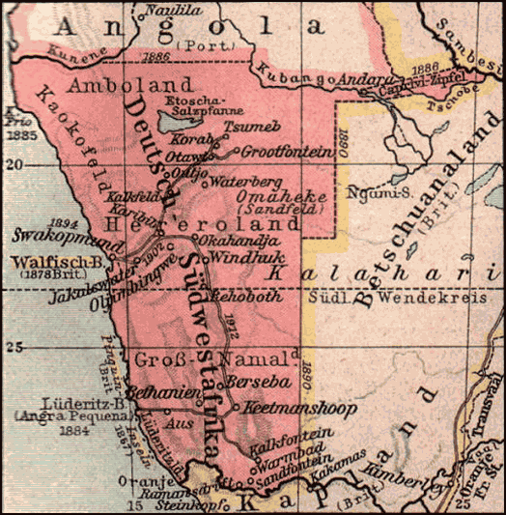 Case Studies of European rule in Africa: (1) GSWA; (2) Belgian Congo 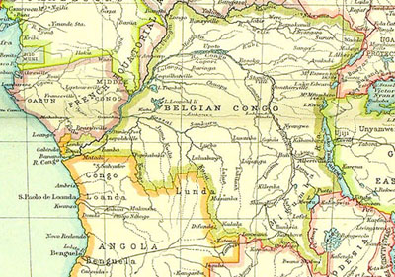
Political system

Economic activity

Social impact

Effects on Europe…

