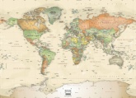 Andrew Marr’s History of the World – ep 6 – the Colonies 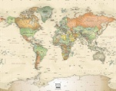

- What did the UK Parliament stand for ?

- What was British about the way the Colonies were governed ?

- What wasn’t British about the Colonies?

- Why were taxes a problem for the colonists ?

- Who took action against which tax?

- What did they do?

- Why was this important?

