The stench of the hold while we were on the coast was so intolerably loathsome, that it was dangerous to remain there for any time, and some of us had been permitted to stay on the deck for the fresh air; but now that the whole ship's cargo were confined together, it became absolutely pestilential. Olaudah Equiano (c1745-1977),

The closeness of the place, and the heat of the climate, added to the number in the ship, which was so crowded that each had scarcely room to turn himself, almost suffocated us. This produced copious perspirations, so that the air soon became unfit for respiration, from a variety of loathsome smells, and brought on a sickness among the slaves, of which many died — thus falling victims to the improvident avarice, as I may call it, of their purchasers. Olaudah Equiano (c1745-1977),

This wretched situation was again aggravated by the gaffing of the chains, now became insupportable, and the filth of the necessary tubs, into which the children often fell, and were almost suffocated. The shrieks of the women, and the groans of the dying, rendered the whole a scene of horror almost inconceivable. Olaudah Equiano (c1745-1977),

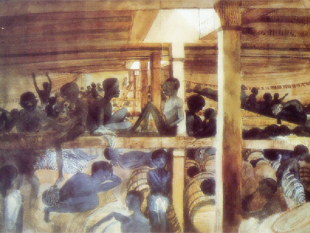
View of the Deck of the Slave Ship Alabanoz by Lieutenant Francis Meynell, 1846

"A woman was dejected from the moment she came on board, and refused both food and medicine; being asked by the interpreter what she wanted, she replied ‘nothing but to die’, and she did die".
Alexander Falconbridge, a former slave ship’s surgeon wrote his Account of Slave Trade on the Coast of Africa in 1788

Others chose to express their resistance more violently – "a man sold with his family for witchcraft", testified Dr Trotter at the parliamentary select committee, "refused all sustenance after he came on board. Early the next morning it was found that he had attempted to cut his own throat. [Dr Trotter] sewed up the wound, but the following night the man had not only torn out the sutures, but had made a similar attempt on the other side. He declared that he would never go with white men…he died of hunger in eight or ten days".
Alexander Falconbridge, a former slave ship’s surgeon wrote his Account of Slave Trade on the Coast of Africa in 1788

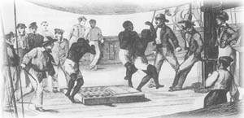

Africans being forced to 'dance' on board ship.
Illustration from 'France Maritime' by Grehan Amedee

